**Project Documentation**

Document Version 1.0

**17 - May - 2021**

Author : Ajunumasa Sadanandan

**Quiz App**

Contents

1. About this Document 2

1.1 How this Document is organized 2

1.2 Contact Information 2

2 . Introduction 3

2.1 Objectives 3

3 . Flow chart 4

4. Sprint planning 5

5 Solution Overview 6

6. Github link 7

# About this Document

This functional and integration (FIS) document will enable you to understand the proposed solution for the creation of Quiz App.

The content of the document will have a solution and its configuration details as it will be available for our client.

### How this Document is organized

This document is organized into the following chapters:

Chapter 2 - "Introduction" provides solution scope to be delivered to our client.

Chapter 3 - "Flow Chart" explains the execution of flow of the App.

Chapter 4 - "Sprint Planning" how the project was developed in each phase.

Chapter 5 - "Solution Overview" provides how the solution of the project is .

Chapter 6 - “Github link” provides the information on where the project is located.

### Contact Information

Quiz App welcomes your comments and suggestions on the quality and usefulness of this document. For any questions, comments, or suggestions on the documentation, you can contact us at the following address:

**For India Enquiry**

Ajunumasa Sadanandan

**Quiz App**

**contact_us@quizapp**

# . Introduction

This document describes the implementation of *Quiz App* and how its users can interact with the application.

Quiz App is a platform where we give exam.

### Objectives

The objective of this document is to describe how the solution of Q*uiz App* will integrate with the User.

This document also provides information on end-to-end workflow flow so that business users can understand the features and functionalities of the *Quiz App.*

The workflow mainly involves the following important aspects,

* + 1. **Trivia API which is a API to generate random questions**
    2. **For every right answer given by the user they are awarded with 10 points and -5 for very wrong answers.**

# . Flow chart

* 1. **The objective of this session if to show how the user interacts with the user flow of the**

Sporty Shoes Pvt. Ltd

***.***



## **Sprint planning**

* 1. **This section tells how the workload was sliced into smaller part and was completed.**

###### For effective pace and efficiency a trello board was managed as shown below.

###### It was divided into three parts

###### Task to do.

###### In Progress

###### Completed in Sprint 1

###### The timebox for each sprint was 1 week .

**Sprint 1**

###### The sprint 1 overall working flow of the application was done.

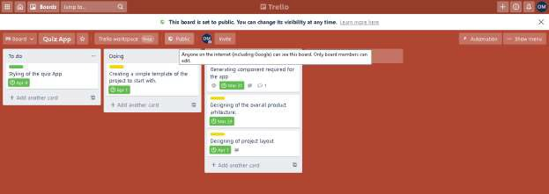

**==========================================================================**

**The complete activity of the sprint can be seen from the below link. Click here: -** <https://trello.com/b/oxqYy7Dh/quiapp>

# Solution Overview

**Platform requirement**

The platform used for this project is the angular, node js, VS code.

#### UI for User:-

Below is the welcome page of the application

**====================================================================**

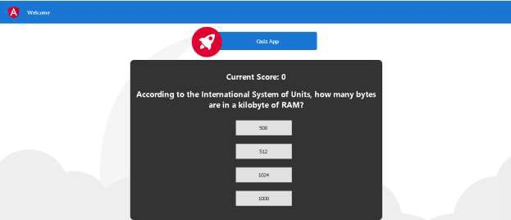

**===================================================================**

##### **Step 1:- The above page is displayed for the user to solve the question and answers.**

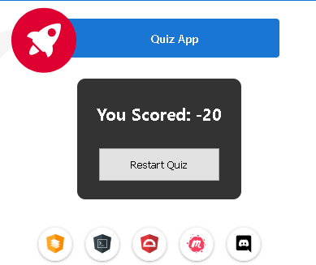

Step 2 - After completion of the quiz the following page is displayed.

# 6. Github link

This section lists where the source code is located and from where the user can download and use it.

<https://github.com/ajunumasa/Phase4-QuizApp-main>